SECTION 4: SOCIO-ECONOMIC PROFILE

INTRODUCTION

The purpose of this section is to provide an overview of the current social status of the population in Makhado in terms of demographics, education levels, poverty rate, employment status and household income. The section also provides an assessment of the implications of the social dynamics on all spheres of development.

The study area is compared to provincial and national figures throughout the section in order to view relative status.

The outline of this section is as follow:

- Social Indicators
- Demographics
- Human Development Index (Hdi)
- Household Income, Expenditure and Poverty
- Education and Skills
- Mode of Travel to Work or School
- Dwelling Type
- Household Size
- Access to Services
- HIV Aids
- Conclusion

SOCIAL INDICATORS

The social analysis reflects the status quo of the demographic and social conditions pertaining to the Study Area. The purpose of this discussion is to reflect a qualitative and, where possible, a quantitative summary of demographic variables and social infrastructure of the area.

DEMOGRAPHICS

Demographic information is regarded as a vital baseline source for the interpretation, evaluation and projection of social and human resource needs and requirements. In this subsection, the population of Makhado is discussed in order to provide a holistic overview and identify specific population issues which impacts on local economic development of the area.

POPOUALTION

The population in Makhado is estimated at 515 049 people, which represents about 9.4% of the provincial and 41.4% of the district population respectively. Table 4.1 represents the population by gender of Makhado Municipality.

Table 4.1: Population by Gender
Population by gender | South Africa
 | 1996 | 2001 | 2004
Population | 41 253 392 | 4 455 182 | 45 857 654
% Male | 48.0% | 48.0% | 48.0%
% Female | 52.0% | 52.0% | 52.0%
 | Limpopo
Population | 5 004 102 | 5 259 673 | 54 669 31
% Male | 45.5% | 47.1% | 47.5%
% Female | 54.5% | 52.9% | 52.5%
 | Vhembe
Population | 1 121 028 | 1 189 815 | 1 245 015
% Male | 45.0% | 46.6% | 47.1%
% Female | 55.0% | 53.4% | 52.9%
 | Makhado
Population | 458 153 | 497 090 | 515 049
% Male | 44.9% | 46.4% | 46.9%
% Female | 55.1% | 53.6% | 53.1%
Source: Statistics South Africa, 2001/Quantec Database, 2005

The population in Makhado consist of 46.9% male and 53.1% female. Although there are more females than males in the study area, the pattern in the gender distribution is very similar to district, provincial and national distribution.

Figure 4.1: Population Group of Study Area
 | 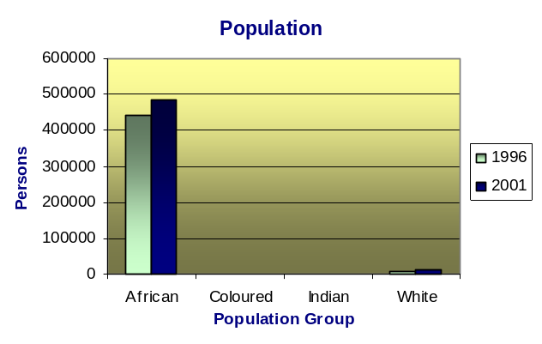
  Persons | 1996 | 2001
  African | 96.8% | 97.4%
  Coloured | 0.2% | 0.2%
  Indian | 0.2% | 0.3%
  White | 2.2% | 2.1%
  Total Population | 458153 | 497090
Source: Municipal Demarcation Board, 2001

According to the 2001 census, the majority of Makhado’s population consist of Africans (97.4%). Approximately 2.1% of the population is White, 0.3% is Indian and 0.2% is Coloured.

AGE AND GENDER

The age and gender profile for the Study Area is illustrated in Figure 4.2. According to the profile the largest population group is female between the ages of fifteen and thirty four years old. This group comprises 18.9% of the total population in the area. The smallest population group is males above the age of 65. In total the dominant gender is female, consisting of 55.3% of the total population.

The age structure of Makhado is relatively young with 73.9% of the residents being younger than 34 years of age. It is important to note that the age group 15-64 represents the main part of the population that are economically active. In this age group males represent 23.2% and females 30.8% of the total population. This raises concern because this group has to support the rest of the population (46%). It should also be kept in mind that many people in this age category leave the area in search of employment opportunities.

The study area houses relatively few people older than 65 years of age. Males above 65 constitute 1.8% of the population while females accounts for 4.8% of the total population in the area.

Figure 4.2: Population by age and gender
 | 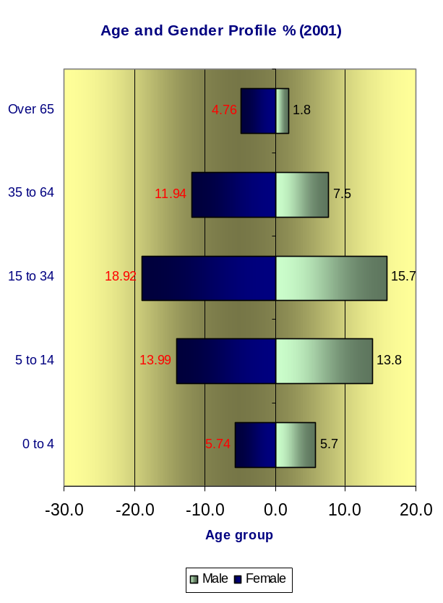
  Age group | Male | Female | Total
  0 to 4 | 5.7% | 5.7% | 11.4%
  5 to 14 | 13.9% | 14.1% | 28.0%
  15 to 34 | 15.7% | 18.9% | 34.6%
  35 to 64 | 7.5% | 11.9% | 19.4%
  Over 65 | 1.8% | 4.8% | 6.6%
  Total | 44.6% | 55.4% | 100.0%
Source: Municipal Demarcation Board, 2001

POPULATION GROWTH

The population growth of the Makhado region displayed a positive population growth rate of 1.4% over the study period. For the same period the national population growth was approximately 1.04% and the provincial population growth was estimated to be approximately 1.3%.

Table 4.2: Population growth 2000-2004
Average annual population growth (2000-2004)
Makhado | 1.40%
Limpopo | 1.28%
South Africa | 1.04%
Source: Statistics South Africa, 2001/Quantec Database, 2005

It is evident from Table 4.2 that the population growth in Makhado is relatively high compared to the provincial and national population growth. The average annual population growth in Makhado is 0.12% higher than the provincial population growth and 0.36% higher than the national population growth rate.

HUMAN DEVELOPMENT INDEX (HDI)

The HDI is a summary measure of human development. The HDI measures the average achievements in an area in three basic dimensions of human development:

- A long and healthy life, as measured by life expectancy at birth
- Knowledge, as measured by the adult literacy rate (with two-thirds weight) and the combined primary, secondary and tertiary gross enrolment ratio (with one-third weight)
- A decent standard of living, as measured by GDP per capita.

The unemployment rate in Limpopo is 36.1%, which is the highest in South Africa, whereas, the households under the poverty line of R800 per month are 36.4%. This situation is much worse than the national rate.

The Human Development Index for Limpopo Province is 0.63 which is lower than the national HDI (0.69). The HDI for Makhado is 0.65 indicating that relatively higher life expectancy, income and literacy levels are present in Makhado than in Limpopo, although it is still lower than the national average.

The poverty gap in Makhado represents 0.5% of the poverty gap in Limpopo Province. This ranks Makhado as an area with one of the highest poverty gaps in Limpopo Province.

HOUSEHOLD INCOME, EXPENDITURE AND POVERTY

In order to determine the people’s living standards as well as their ability to pay for basic services such as water and sanitation, the income levels of the population are analysed and compared to the income levels of Limpopo. In figure 4.3 the distribution of the number of households per income group in Makhado is shown.

Figure 4.3: Household income
 | 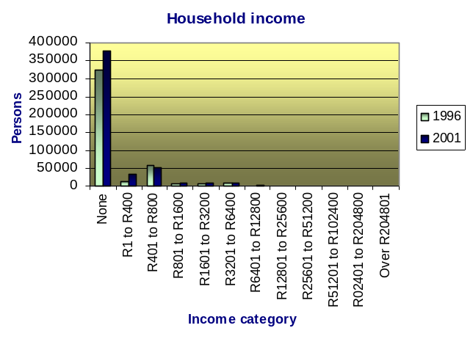
   | Makhado
  Income Category | 1996 | 2001
  None | 76.3% | 75.9%
  R1 - 400 | 3.3% | 6.7%
  R401 - 800 | 14.2% | 10.8%
  R801 - 1600 | 1.8% | 2.0%
  R1601 - 3200 | 1.4% | 2.0%
  R3201 - 6400 | 2.5% | 1.7%
  R6401 - 12800 | 0.3% | 0.6%
  R12801 - 25600 | 0.1% | 0.1%
  R25601 - 51200 | 0.0% | 0.0%
  R51201 - 102400 | 0.0% | 0.1%
  R102401-204800 | n/a | 0%
  Over R204801 | n/a | 0%
  Total | 100% | 100%
Source: Municipal Demarcation Board, 2001

In figure 4.3 it is evident that the largest share of the economically active population in Makhado earns less than R3200 per month. This trend is very similar to that of Limpopo Province. A very small share of the economically active population (15 – 64 years of age) in Makhado earns R12 800 and more per month, while a much larger share of the economically active population in the province fall in this category.

It is also evident in the table above that the majority of the population in Makhado are very poor and are experiencing relatively low living standards and a poorer quality of life. These low income levels indicate that the majority of the population is dependant on a small income implying that the local population of Makhado are not able to afford basic services such as water and sanitation. These poverty levels also do not enable these people to afford the cost of educational needs of their children.

EDUCATION AND SKILLS

Figure 4.4 illustrates the level of education in Makhado Local Municipality. About 21.2% of the study area population, above 20 years of age, have a Grade 12 or higher education qualification, while 34.9% have no schooling at all. This has serious implications for employment and money generating opportunities for the population. In total 65.1% of the population in Makhado have some form of schooling and can be regarded as literate. Cognisance should be taken of the fact that these figures include only formal qualifications and does not take technical experience into consideration.

Figure 4.4: Education levels-over 20 year olds
 | 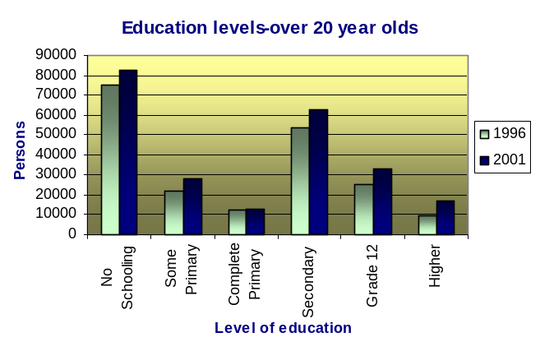
  Education | 1996 | 2001
  No Schooling | 38.0% | 34.9%
  Some Primary | 11.2% | 12.0%
  Complete Primary | 6.2% | 5.5%
  Secondary | 27.0% | 26.4%
  Grade 12 | 12.9% | 14.0%
  Higher | 4.7% | 7.2%
Source: Municipal Demarcation Board, 2001

Figure 4.5 below illustrates the level of skills among the working population of Makhado. The level of skills within an area is important to determine the level of employment.

Figure 4.5: Level of skills among the employed in Makhado, 2001
Level of Skill | 1996 | 2001
Clerks | 5.8% | 7.6%
Craft/Trade | 15.7% | 10.6%
Elementary | 36.4% | 33.0%
Legislators/Senior Officials | 3.1% | 3.4%
Plant/Machine Operators | 6.8% | 6.4%
Professionals | 15.3% | 6.0%
Service Workers | 11.8% | 10.3%
Agricultural/Fishery | - | 4.4%
Technicians | 5.3% | 11.5%
Undetermined | - | 6.8%

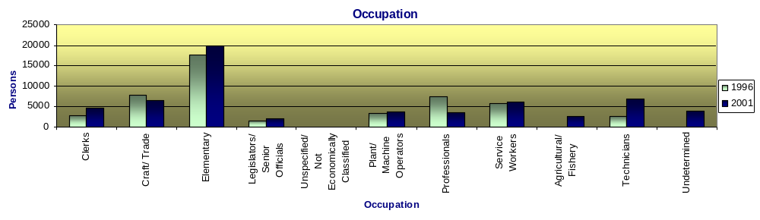

Source: Municipal Demarcation Board, 2001

Approximately 10.6% of the working population in the Study Area has some form of craft and trade related skills that could be used to the benefit of the local economy, 6.4% are plant and machine operators, 10.3% are service workers, shop and market sales workers and 4.4% consist of skills in agriculture and fishery.

MODE OF TRAVEL TO WORK OR SCHOOL

The figure below illustrates the major modes of transport used to get to work or school by the residents in Makhado.

Figure 4.6: Mode of travel to work/school
 | 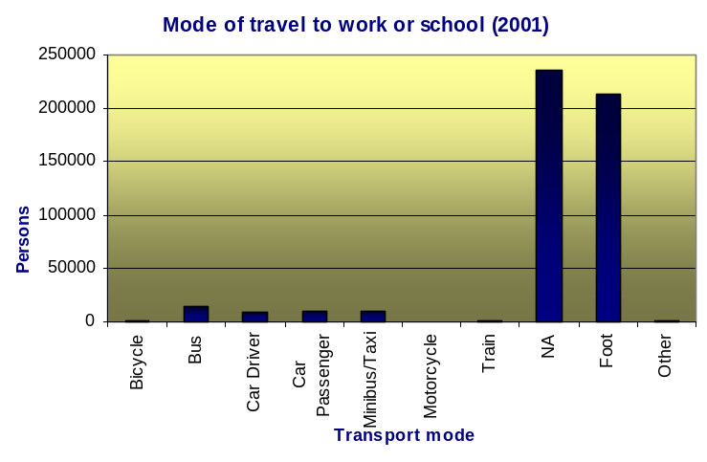
  Mode | 2001
  Bicycle | 0.2%
  Bus | 3.0%
  Car Driver | 1.7%
  Car Passenger | 2.2%
  Minibus/Taxi | 2.0%
  Motorcycle | 0.1%
  Train | 0.2%
  NA | 47.4%
  Foot | 42.9%
  Other | 0.2%
Source: Municipal Demarcation Board, 2001

It is evident form the above table and figure that the majority of the population (42.9%) walk to their destinations. Approximately 3% make use of buses, 2.2% are passengers in a private vehicle, 2% uses a minibus or taxi, 1.7% has their own car, 0.2% uses trains and 0.2% makes use of a bicycle as their primary mode of transport to work or school. About 47.9% does not attend work or school and it is therefore not applicable.

DWELLING TYPE

The following figure illustrates forms of dwelling types per household in Makhado for 1996 and 2001.

Figure 4.7: Dwelling type
 | 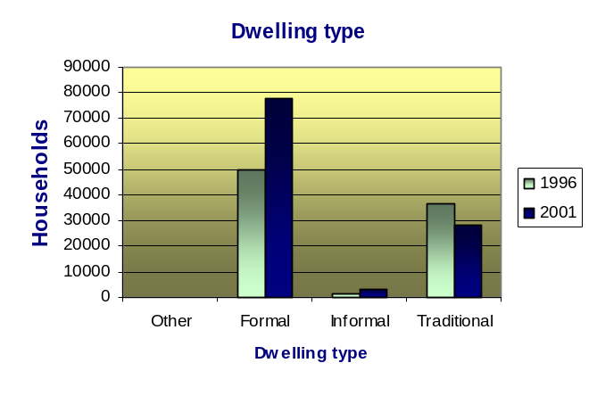
  Dwelling Type | 1996 | 2001
  Other | 0.2% | 0.2%
  Formal | 56.4% | 71.5%
  Informal | 1.6% | 3.0%
  Traditional | 41.8% | 25.3%
Source: Municipal Demarcation Board, 2001

The majority of households (71.5%) in Makhado have formal dwelling types and the proportion increased with 15.1% from 1996. The amount of informal dwelling units also increased which indicates the effect of the rapid population growth in the area. Traditional housing on the other had decreased from 41.8% in 1996 to 25.3% in 2001.

HOUSEHOLD SIZE

The following figure categorises the households in Makhado according to the size of the households.

Figure 4.8: Household size
 | 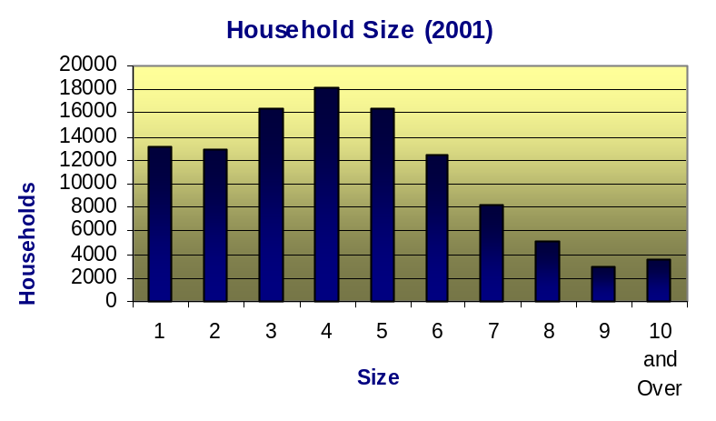
  Household Size | 2001
  1 | 12.0%
  2 | 11.8%
  3 | 14.9%
  4 | 16.7%
  5 | 15.0%
  6 | 11.4%
  7 | 7.5%
  8 | 4.6%
  9 | 2.8%
  10 and Over | 3.3%
Source: Municipal Demarcation Board, 2001

Most of households consist of between 3 and 5 persons per household. About 30% of households consist of 6 or more people per household, which is above the national average. The average household size of households in Makhado is approximately 4.6 persons per household.

ACCESS TO SERVICES

The following tables illustrate development according to specific development indicators or services. Households in the area display growth in access to household electricity, refuse removal, sanitation facilities, access to water and telephones.

Source of Energy/ Lighting

The following figure illustrates the source of electricity used for lighting by households in Makhado.

Figure 4.9: Source of energy for lighting
 | 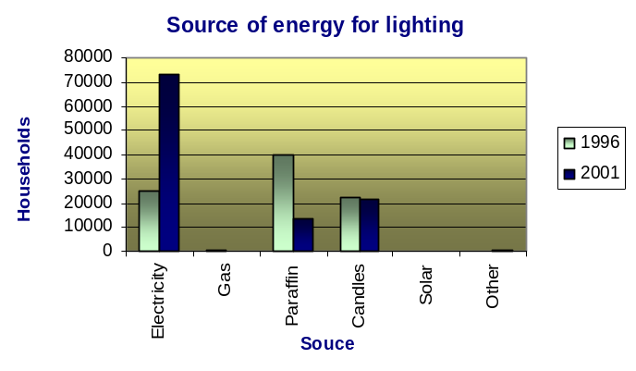
  Source | 1996 | 2001
  Electricity | 28.7% | 67.0%
  Gas | 0.7% | 0.2%
  Paraffin | 45.4% | 12.5%
  Candles | 25.2% | 19.5%
  Solar | n/a | 0.3%
  Other | 0.0% | 0.5%
Source: Municipal Demarcation Board, 2001

It is clear in figure 4.9 that the number of households with access to electricity increased dramatically between 1996 and 2001. It increased from 28.7% to approximately 67%, which means that the number of households with access to electricity in 2001 was more than double the amount in 1996.

Refuse

Figure 4.10 shows the level of access to refuse facilities among households in Makhado.

Figure 4.10: Refuse
 | 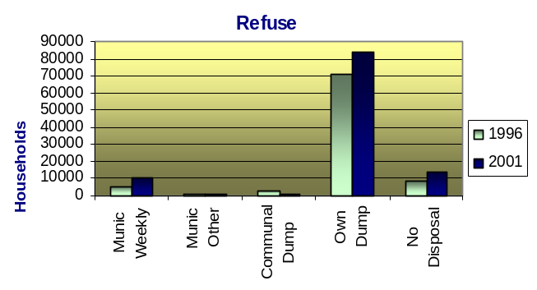
  Refuse | 1996 | 2001
  Municipal Weekly | 6.4% | 9.4%
  Municipal Other | 1.0% | 0.5%
  Communal Dump | 2.5% | 0.7%
  Own Dump | 80.6% | 76.8%
  No Disposal | 9.5% | 12.6%
Source: Municipal Demarcation Board, 2001

It is clear that the percentage of households that has access to weekly municipal refuse services increased from 6.4% to 9.4%. Although the number of households that has their own dumps decreased from 80.6% to 76.8%, it still represents the majority of households in Makhado, which can have major implications for health conditions in the area. The amount of households with no access to refuse facilities has also increased due to population growth.

Sanitation

Figure 4.11 represents the access to sanitation facilities among households in Makhado. It distinguishes between households with access to flush toilets, flush septic tanks, chemical toilets, VIP’s, pit latrines, bucket latrines and those households that have no access to sanitation facilities.

Figure 4.11: Sanitation
 | 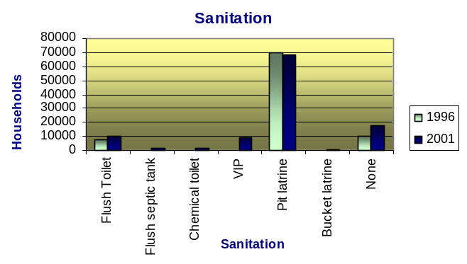
  Sanitation | 1996 | 2001
  Flush Toilet | 8.6% | 9.5%
  Flush septic tank | n/a | 1.7%
  Chemical toilet | n/a | 1.3%
  VIP | n/a | 8.1%
  Pit latrine | 79.2% | 62.4%
  Bucket latrine | 0.4% | 0.7%
  None | 11.8% | 16.3%
Source: Municipal Demarcation Board, 2001

Although the percentage of households with access to flush toilets have increased since 1996 to 2001, the majority of households still make use of pit latrines or have no access to sanitation facilities at all.

Telephone

Figure 4.12 shows the percentage of households with access to telephones, cellphones, a neighbour’s phone or public phone as well as those households without any access to any form of phone.

Figure 4.12: Telephones
 | 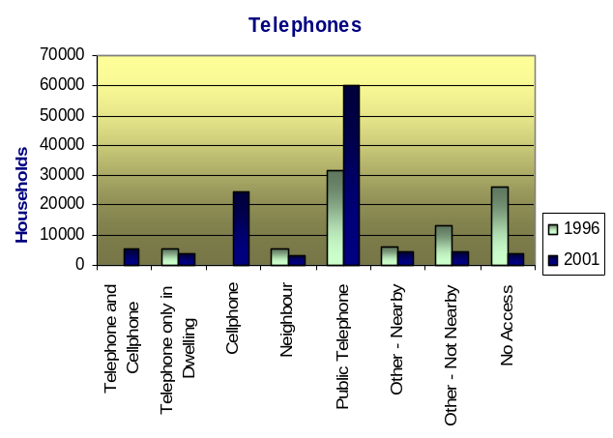
  Telephone | 1996 | 2001
  Telephone and Cellphone | n/a | 4.8%
  Telephone only in Dwelling | 6.3% | 3.6%
  Cellphone | n/a | 22.3%
  Neighbour | 6.1% | 2.8%
  Public Telephone | 35.8% | 55.0%
  Other - Nearby | 6.6% | 4.0%
  Other - Not Nearby | 15.2% | 4.1%
  No Access | 30.0% | 3.3%
Source: Municipal Demarcation Board, 2001

The majority of households in Makhado make use of Public telephones. Approximately 96% of the population has access to some sort of telephone within walking distance (2001). Only 54.8% of the population had access to a telephone in 1996, which indicates that the accessibility increased tremendously over that period (with 41.2%).

Water

The following figure illustrates the percentage of households with access to water facilities in Makhado in 1996 and 2001 respectively.

Figure 4.13: Water
 | 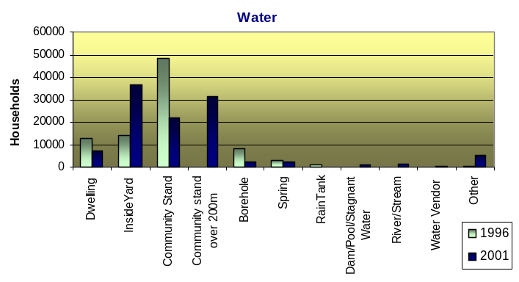
  Water | 1996 | 2001
  Dwelling | 14.4% | 6.8%
  Inside Yard | 16.2% | 33.3%
  Community Stand | 54.6% | 20.1%
  Community stand over 200m | n/a | 28.4%
  Borehole | 9.5% | 2.2%
  Spring | 3.3% | 2.0%
  Rain Tank | 1.2% | 0.1%
  Dam/Pool/  Stagnant Water | n/a | 0.7%
  River/Stream | n/a | 1.4%
  Water Vendor | n/a | 0.3%
  Other | 0.8% | 4.8%
Source: Municipal Demarcation Board, 2001

HIV AIDS

Table 4.3 below illustrates the proportion of Makhado’s population that are HIV+ as well as AIDS related deaths as a percentage of the total deaths in this area in 2004. These figures are also compared to Limpopo and South Africa in order to evaluate the Study Area in Provincial and National context.

Table 4.3: Makhado Population – HIV/AIDS
 | South Africa | Limpopo | Makhado
% of population HIV+ | 10.9% | 9.1% | 9.0%
AIDS related deaths (% of total deaths) | 46.7% | 40.2% | 39.0%
Source: Statistics South Africa, 2001/Quantec Database, 2005

Although 9% of Makhado’s population is HIV+, it is still lower than the provincial and national total. Approximately 39% of total deaths in Makhado are AIDS related, which is lower than the provincial and national total.

CONCLUSION

From the preceding analysis it is evident that certain issues requires more attention than others.

The demographic and social situation presents the following challenges and threats to local economic development:

- The Study Area has a predominantly youthful population, with approximately 39.2% of the total population being younger than 15 years of age. Only about 54% of the total population represents the economically active proportion. This implies a smaller percentage of income generating population and therefore a high dependency ratio.

- The study area is mostly rural, which implies higher unemployment rates and high costs of providing infrastructure due to dispersed settlement patterns that are often associated with rural areas.

- The majority of residents walk to their destinations (work/school). This implies that facilities should be supplied within walking distance of the residential area and there might be a need for more efficient transport planning and provision of other travel alternatives.

- The low monthly income of residents in the Study Area implies that there are insufficient disposable income and therefore low buying capacity per household. This implies negative implications for the trade sector and especially for the survival of local businesses in the area. The low income levels also limit the majority of households in the area to pay for basic services and municipal rates and taxes. This impact on the municipal financial sustainability.

- The low purchasing power within the area is likely to discourage prospective investors to the area.

- Although the HIV/AIDS projections for Makhado are relatively lower than the provincial and national total, it still poses a threat to development in the area. This may worsen the dependency situation where more people become dependant on fewer income-earning individuals. This will increase the poverty levels in the area and put pressure on government resources in terms of payments of grants subsidisation of services payments. A high death rate among the economically active population group also translates into the loss of skills and knowledge as well as a decrease in productivity due to illnesses and a shortage of local skills.

- The low education levels in the study area present serious challenges in terms of the availability of skills required for employment opportunities that might be created in the area.

